Welcome to Lyfta 🎉

This introductory worksheet is your first step towards bringing the immersive world of Lyfta into your classroom. This tutorial will guide you through the platform, highlighting key features as you embark on your first session. As you complete this sheet, you'll be prompted to engage with tasks and reflections to deepen your understanding of what Lyfta offers and we’ll also share some initial tips and signposts to support you in curating your first adventures.

Your name(s) and school:

|  |
| --- |
|  |

# **What is Lyfta?**

If you are completely new to Lyfta, this short video is a great place to start. If Lyfta has already been introduced to you - feel free to jump to the next section where we’ll begin exploring the platform. **Click the link on the image to open the 2 minute video.**

# 

# **Introducing Lyfta’s search 🔍**

The search function is the place to find the content you want to teach. [**This video will introduce our search.**](https://help.lyfta.com/en/articles/5744938-video-1-introducing-lyfta-s-search-and-how-to-start-teaching)

We would also like to highlight *collections* through [**this video**](https://help.lyfta.com/en/articles/8650823-video-lyfta-collections). Collections are groups of content based around curriculum topics, values, and other focus areas. It is worth checking with your Lyfta Lead about your school implementation plan, as you may want to save some of these collections for later by hitting the subscribe button.

Once you have watched this video and completed your search, come back to this worksheet and let us know what content you uncovered.

|  |
| --- |
| Some of the content I explored is…   * Lyfta Time 1 - Rob in Cornwall |

# **Teaching with Lyfta - Introducing Lyfta Times 🎓**

We recommend that colleagues begin their Lyfta journey with our ‘Lyfta Time’ series. Lyfta times are shorter lessons (about 20-25 minutes) which follow the same structure each time, and systematically work through our storyworlds - bringing the story of a new person and place into your classroom each session - although one storyworld can be explored over several sessions.

[**These videos**](https://teacher.lyfta.com/search/lyfta-lessons/previews/2209?product_tour_id=443737) introduce our lesson plans and then guide through your first Lyfta Time lesson - remember, each Lyfta Time will follow the same structure!

After you follow along with this tutorial, come back to this worksheet and think about the following questions:

|  |
| --- |
| Imagine showing your students this Storworld with Rob in Cornwall.  What might your students think Rob is doing?  What might your students notice or ask about in this storyworld? |

|  |
| --- |
| Lyfta Time lessons are all discussion based. Other Lyfta lessons are full length and include on and off-screen learning activities. If you were to extend this discussion lesson into another learning activity for your students, what could that be? |

🏆The recommended implementation route is to start with at least one Lyfta Time each week. Often schools encourage all classes to do the same Lyfta Times each week in order to open up inter-class and whole school learning opportunities, but some like to select Lyfta Times according to class topics, curriculum themes or age groups - your Lyfta Lead will have discussed their preferred implementation route with us.

[**Here**](https://teacher.lyfta.com/search-content?query=lyfta+time&sortby=name) you can find our complete Lyfta Times series.

[**Here**](https://teacher.lyfta.com/search-content?query=lyfta+time&sortby=name&filters=%7Btypes%3Dcollection%7D) you can find collections of Lyfta times around [**our focus areas**](https://www.lyfta.com/focus-areas) and more!

# **Lyfta for your Key Stage 🎒**

We have lesson plans and resources differentiated for each key stage. However, it’s important to remember that activities and strategies you normally use with your classes can also be used with Lyfta. For additional tips, our help hub contains activity banks, toolkits, guided walkthroughs and advice from other schools and trusts about getting the most value from Lyfta at each key stage (for example, there are some alternative suggestions for working with younger children or children with SEND). [**Check out ‘how educators use Lyfta’ on the help hub**](https://help.lyfta.com/en/)!

If you ever feel like you would like to talk through teaching strategies or ideas for your key stage or school more widely, please do reach out to [info@lyfta.com](mailto:info@lyfta.com) . We love working closely with our community and would be delighted to support you in achieving your goals through Lyfta!

# **Additional resources to note ✍️**

[The Lyfta Calendar](https://www.lyfta.com/content-calendar): find resources for upcoming

days of note and events in school

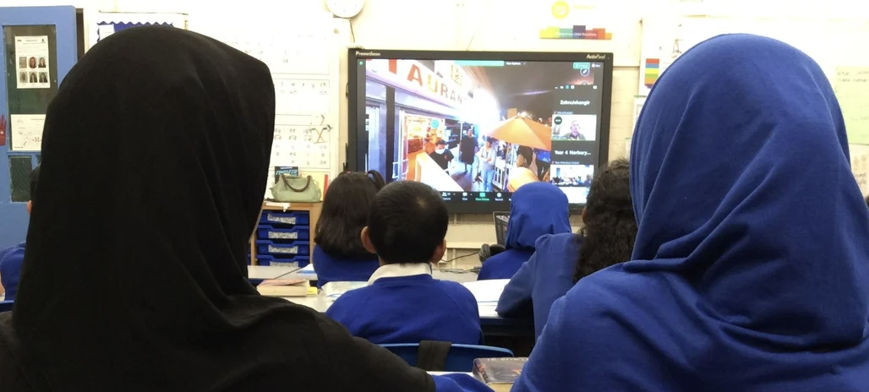

[Live lessons](https://impact.lyfta.com/live-lessons): join hundreds of other classes in one of our live, guided experiences.



[Professional development webinars](https://help.lyfta.com/en/articles/5977796-deepening-practice-with-lyfta?_gl=1*1exvzqm*_ga*NTczODQwMTM0LjE2OTgxNTU1NjE.*_ga_GP0YH7JCLK*MTcwOTcxMDUzOC4zMzQuMS4xNzA5NzEzOTU3LjAuMC4w): we run regular webinars around a wide range of themes, free to join as part of your subscription!

# **Safeguarding and Pedagogy**

You may have noticed that some of our content has the traffic light (  ) symbol next to it. [Click here to learn more about why](https://teacher.lyfta.com/search/lyfta-lessons/previews/2483?product_tour_id=447882) this symbol appears and how it supports meeting the needs of all learners.

Lyfta pedagogy emphasises that the short documentary stories on Lyfta are only a small part of a much wider and complex human story. No story is ever fully representative of a human being or any group they are part of. Our films show only a slice of life and we encourage you to always show the full documentary in its entirety. [Our critical documentary lesson plan](https://student.lyfta.com/lesson-plan/5253) is an important teacher-facing training tool where you can learn about why we make these recommendations and how we select Lyfta content. We look forward to working with you towards a future where every young person has had at least one meaningful, real-world learning experience from every country in the world.

# **Lyfta’s Theory of Learning 🧠**

[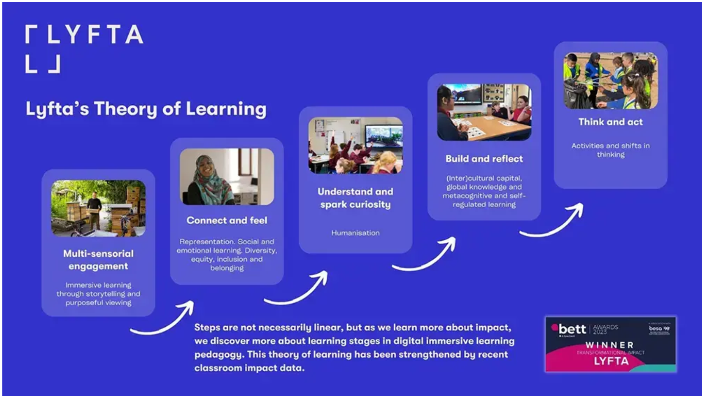](https://vimeo.com/919932512/4527447085?share=copy)

The above image visualises Lyfta’s Theory of Learning and the steps towards impact that Lyfta has in schools. To learn more about the pedagogy and research surrounding this, please view [**this video**](https://vimeo.com/919932512/4527447085?share=copy)of Dr Harriet Marshall, Director of Education and Impact, as she discusses Lyfta’s Pedagogy and its importance.

# **How to submit your completed worksheet 📤**

**Please follow the instructions in your email for submitting this worksheet.**

If you encounter any problems while completing this worksheet, please use the message function in the bottom right corner of teacher.lyfta.com.